What is API gateway ?
- Amazon API Gateway is an AWS service for creating, publishing, maintaining, monitoring, and securing REST, HTTP, and WebSocket APIs at any scale. API developers can create APIs that access AWS or other web services, as well as data stored in the AWS Cloud. As an API Gateway API developer, you can create APIs for use in your own client applications. Or you can make your APIs available to third-party app developers.

PRACTICAL :
- How create API. Go to the API gateway
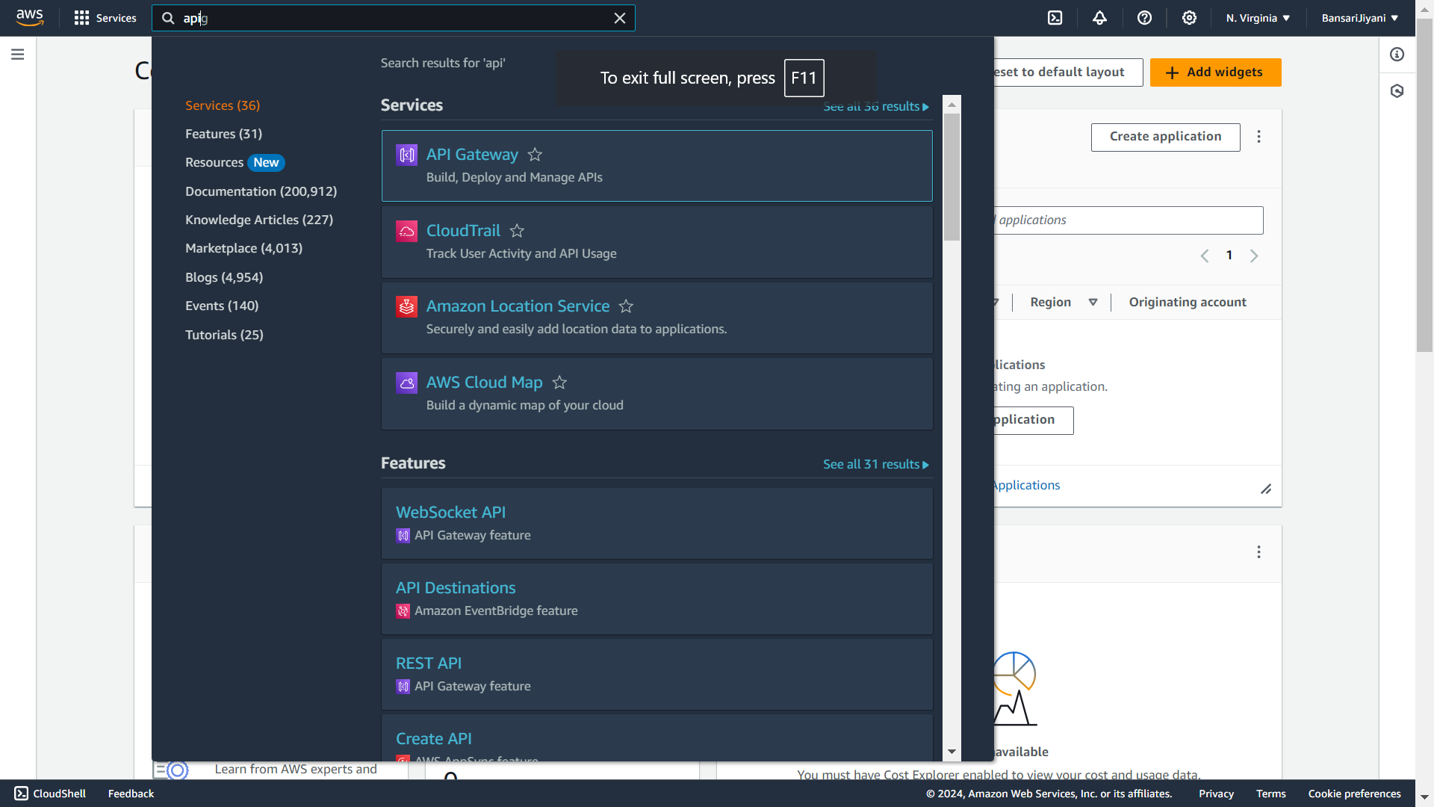
- There is many types of API . you can see here.
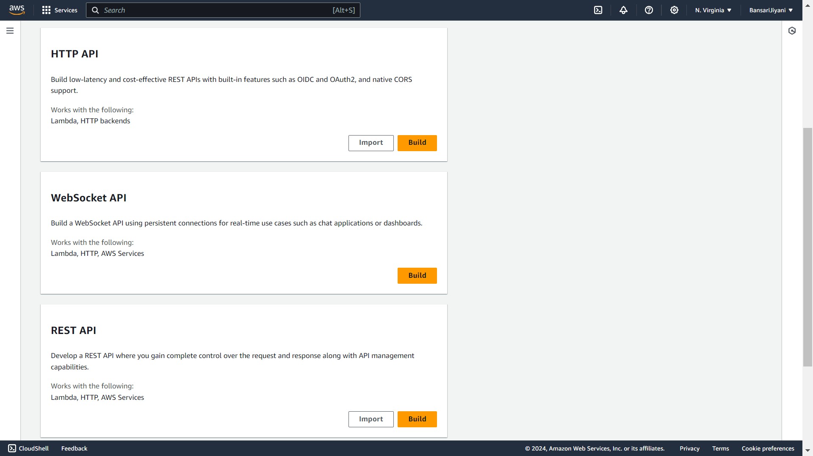

- We create REST API.

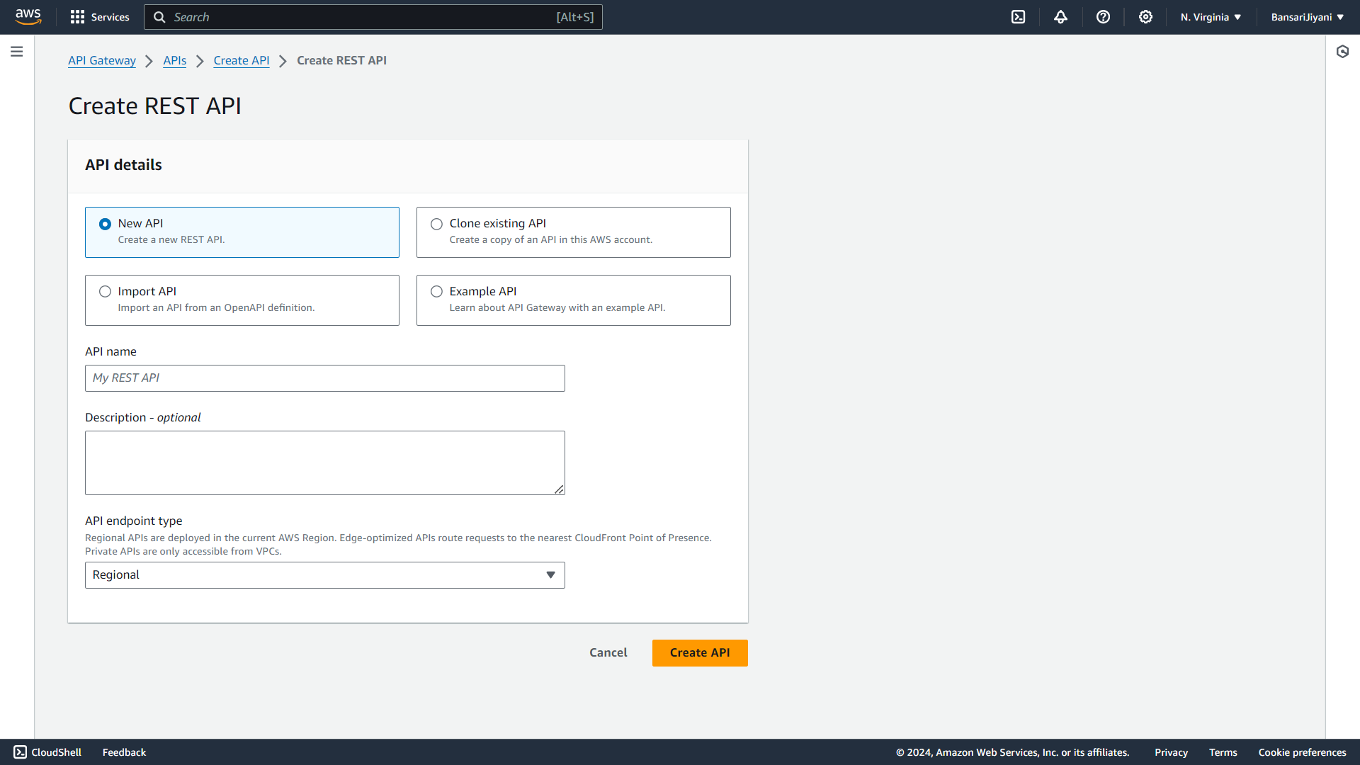
- Give the name of API and select the API endpoint type Regional. And create API.
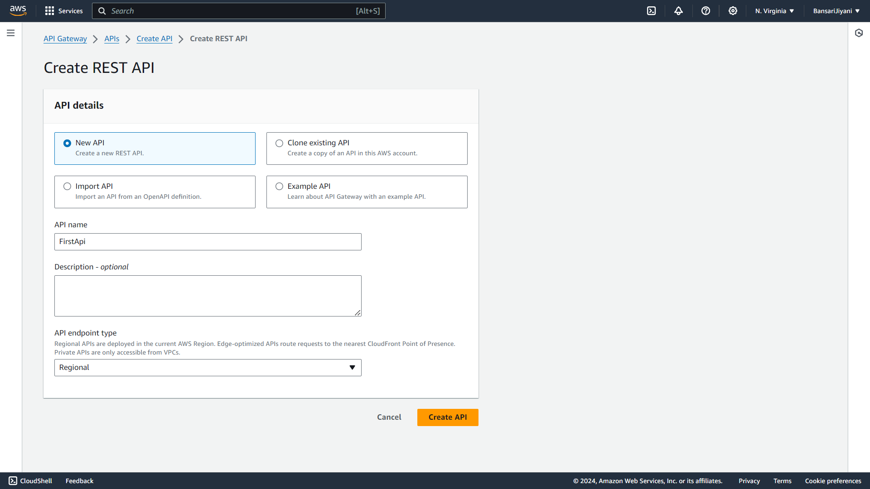

- Our API is successfully created.
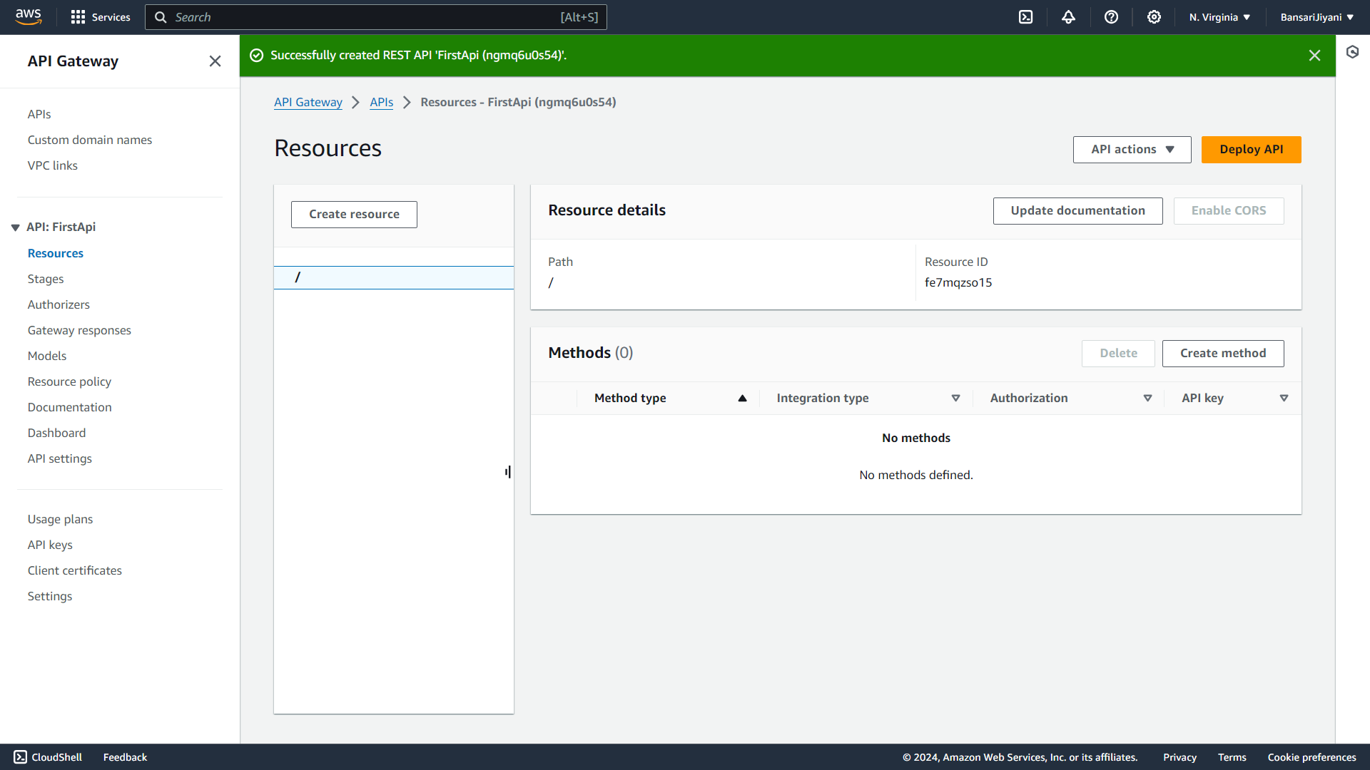
- Create method for API.
